Launch Communication Template

Checklist
Pre Go-Live:
Go-Live Date:
- Announcement Email – 2-3 weeks prior
See Change Canvas to help shape messaging
- Send Pulse Check Survey (provided by Foxo) – included in Announcement email
- Schedule onboarding sessions (per role)
- Reminder Email – 1 week prior to Go-Live
- Send calendar invite to Foxo Connect (1 day prior to Go-Live)
- Prepare Foxo posters, dedicated section on company intranet, flyers, cupcakes, balloons
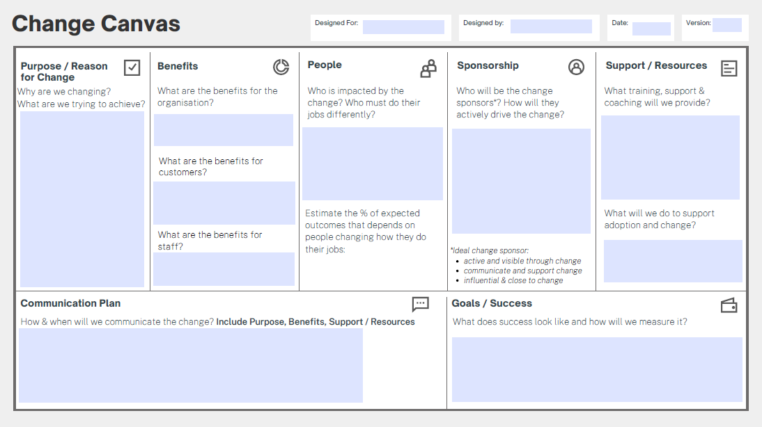
During Go-Live:
- Post on your Organisation’s News Feed (at go-live and beyond)
  - Day 1: e.g. Welcome + Foxo Champions
  - Day 2: Go-live activities: send your first Foxo Message, say hi in the General Team etc.
Post Go-Live:
- Send out Pulse Check Survey Post Go-Live (provided by Foxo)
- Keep using the News feed for important updates
- Lunch & Learn with Foxo Champions

1. Announcement Email
When: 2-3 weeks prior to launch date
Include Why are we changing? What are we trying to achieve?
Subject: Our New Comms Tool is Here – Welcome to Foxo
Dear [First Name],
Our new communication tool has arrived. Foxo is a secure, healthcare-grade platform that will transform the way we communicate and collaborate - improving workflows, and ensuring nothing slips through the cracks.

Why are we changing?
We’ve outgrown tools like WhatsApp or Slack. They are not built for healthcare and pose risks around security, privacy, and information loss.
Foxo is purpose-built for clinical and clerical communication. It’s compliant, structured, integrates with insert your clinical tool – if applicable and designed to support the way we work.

Key Benefits of Foxo: Include benefits for organisation, patients and for staff.
- Privacy & Compliance
ISO 27001-certified and aligned with Australian privacy principles—unlike WhatsApp, Foxo is fully compliant.
- Everything is Tracked and Easy to Find
Full audit history and visibility - no more lost messages, missed threads, or unclear decisions.
- Relevant Communication Only
You’ll only be added to Teams relevant to your role - no more sifting through noise.
- Access Anywhere
Use Foxo via web, desktop, or mobile app—stay connected wherever you are.
- Visage Integration
Seamless connection with Visage to improve workflow efficiencies.
- Built for Healthcare
Structured chat, secure patient and referrer messaging, triaging tools, and more.

What You Need to Do: Include support, resources, Product Champions, training
- Tell us how you're feeling about the change. It takes less than a minute:
👉 Complete the Quick Pulse Check Survey
- Keep an eye out for further emails, and login instructions.
You’ll be fully supported throughout the rollout, with in-department Foxo Champions ready to guide you.
See you soon on Foxo,
[Your Name]
On behalf of the Implementation Team

2. Onboarding Sessions
Dear Team,
As we prepare to launch Foxo, we are organising a short onboarding session to ensure everyone is equipped to use Foxo effectively. Your participation is crucial in ensuring a smooth transition and maximising the benefits of Foxo.
Here’s what to do next:
✅ Choose one of the options - you only need to attend ONE session.
✅ Log in to Foxo (app.foxo.com) use your Microsoft login credentials
✅ Search and join your Team(s)
We look forward to seeing you there!
[Training Session Details]

Best regards,
[Your Name]

3. Pre-Go Live: Calendar Invite to Foxo Connect
When: 1 week prior to launch date
Subject: 🎉 Foxo Connect – Go Live!
Hi everyone,
📅 This is not a meeting, just a friendly reminder in your calendar! Today, we’ll all log in to Foxo together and officially kick things off.
Here’s how you can take part:
✅ Log in to Foxo: [Insert login link]
👋 If you haven’t done so, search for your Team(s) and join.
💬 Send your first Foxo message - in your Team, in the General Chat or to a co-worker
📱 Download the Foxo mobile app: [Insert app link]
↙️ Install the Desktop app
🦊 Explore the platform
Your department's Foxo Champion is here to help if you have questions or need a hand.
See you on Foxo 🦊

4. Pre-Go Live: Reminder Email
When: 1 day prior to launch date
Subject: Are you ready for Foxo tomorrow?
Dear Team,
We’re going live with Foxo tomorrow.
Wait. What is Foxo again?
Foxo is our new communication tool. This new tool is all about making our lives easier by improving how we connect and collaborate across [Organisation Name]. It is integrated in Karisma and compliant with Australian privacy principles.
What You Need To Do? Include support, resources, Product Champions, training
Login tomorrow at the dedicated time.
Complete the activities in the meeting invite:
✅ Log in to Foxo: [Insert login link]
👋 If you haven’t done so, search for your Team(s) and join.
💬 Send your first Foxo message - in your Team, in the General Chat or to a co-worker
📱 Download the Foxo mobile app: [Insert app link]
↙️ Install the Desktop app
🦊 Explore the platform
Please reach out to your location’s Product Champion if you have any questions. They’re here to help.
Add names of Foxo Champions
Best regards,
[Your Name]

5. Go Live: We’re Live Email
On Go-Live Date
Subject: Welcome Aboard: Foxo is Live and Ready for Action
Hi Team!
We're thrilled to announce that Foxo is officially live! 🎉
Dive into Foxo today! Click on this link (app.foxo.com) and log in using your Microsoft credentials.
Need a hand or have feedback? Your Foxo Champion and our implementation team are standing by to help!
Thanks for being part of this exciting journey towards better communication and teamwork!
Here's to many successful Foxo moments ahead!
Best regards,
[Your Name]

